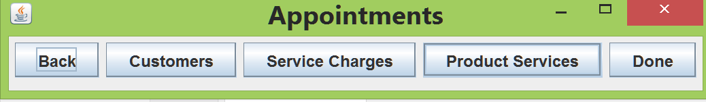

*Service Charges not working(Remove it)*

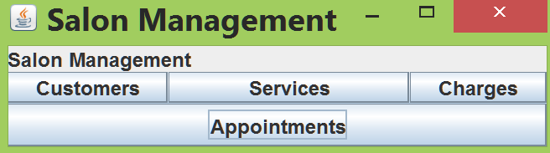

*Service not use remove it.*

*Working button are*

